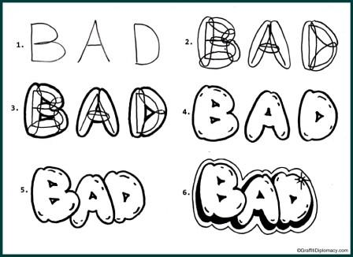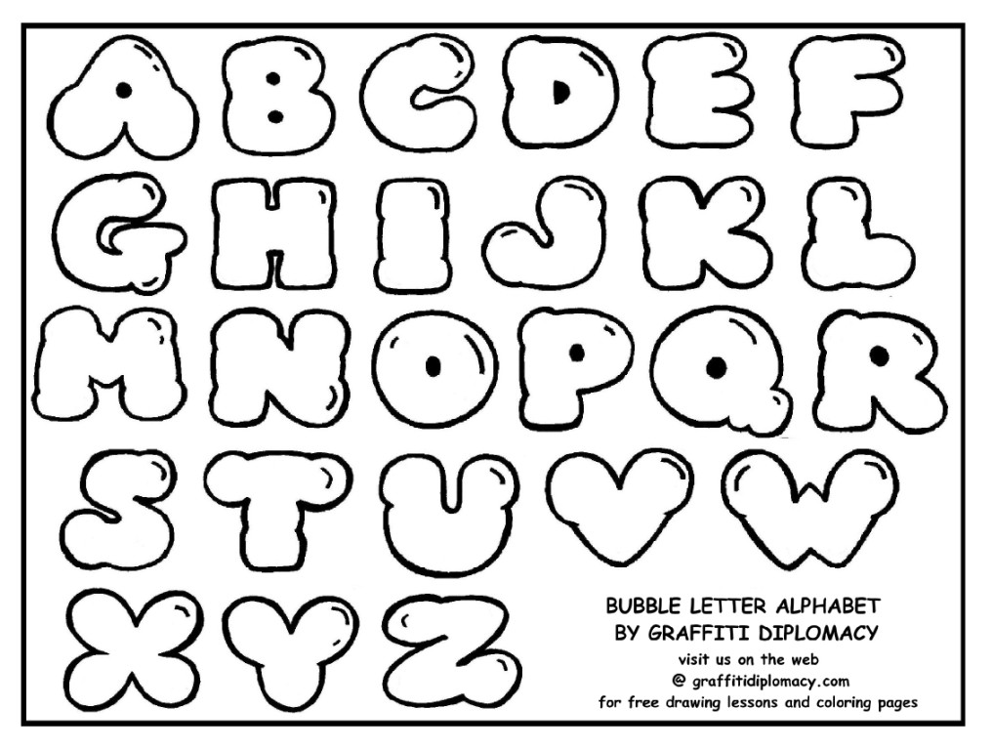[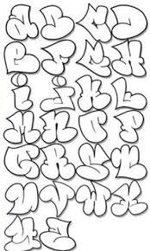](http://www.google.com/url?sa=i&rct=j&q=how+to+draw+bubble+letters&source=images&cd=&cad=rja&uact=8&docid=vBulxM87NBbj8M&tbnid=X9lz2POkK8P1ZM:&ved=0CAUQjRw&url=http://gradeclothing.com/how-to-draw-bubble-letters-for-android.html&ei=GQIGVOHwNIGlyASruYD4CQ&bvm=bv.74115972,d.aWw&psig=AFQjCNEdYJzI9Rlis81Ogsu19tUqrM-tfg&ust=1409766242093382)[](http://www.google.com/url?sa=i&rct=j&q=how+to+draw+bubble+letters&source=images&cd=&cad=rja&uact=8&docid=GGVcCFFiclFmXM&tbnid=wSv4zfn86Q0oFM:&ved=0CAUQjRw&url=http://tattoodrawingpics.com/11029-write-and-draw-graffiti-bubble-letters-for-beginnersgraffiti-bubble&ei=QgIGVOmbJM72yQSU24HABQ&bvm=bv.74115972,d.aWw&psig=AFQjCNEdYJzI9Rlis81Ogsu19tUqrM-tfg&ust=1409766242093382)[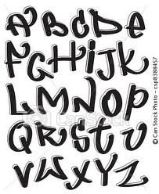](http://www.google.com/url?sa=i&rct=j&q=how+to+draw+bubble+letters&source=images&cd=&cad=rja&uact=8&docid=GGVcCFFiclFmXM&tbnid=wSv4zfn86Q0oFM:&ved=0CAUQjRw&url=http://www.blogdorico.com/2012/12/letras-de-graffiti-fotos-e-imagens.html&ei=VAIGVJmSOJGyyATu2IGABw&bvm=bv.74115972,d.aWw&psig=AFQjCNEdYJzI9Rlis81Ogsu19tUqrM-tfg&ust=1409766242093382)[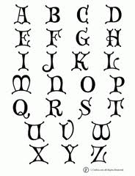](http://www.google.com/url?sa=i&rct=j&q=how+to+draw+bubble+letters&source=images&cd=&cad=rja&uact=8&docid=Gw0yESGxpsCvbM&tbnid=5t487KZJxCK5WM:&ved=0CAUQjRw&url=http://www.classroomjr.com/printable-bubble-letters/&ei=ZwIGVI7DKYWdygTNjIGoDA&bvm=bv.74115972,d.aWw&psig=AFQjCNEdYJzI9Rlis81Ogsu19tUqrM-tfg&ust=1409766242093382)[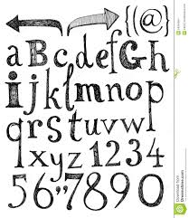](http://www.google.com/url?sa=i&rct=j&q=how+to+draw+bubble+letters&source=images&cd=&cad=rja&uact=8&docid=U25231Dqtd_BhM&tbnid=y7zU0U18vYvumM:&ved=0CAUQjRw&url=http://galleryhip.com/how-to-draw-the-letter-a-in-3d.html&ei=gwIGVKmjPMOfyATQh4Ag&bvm=bv.74115972,d.aWw&psig=AFQjCNEdYJzI9Rlis81Ogsu19tUqrM-tfg&ust=1409766242093382)