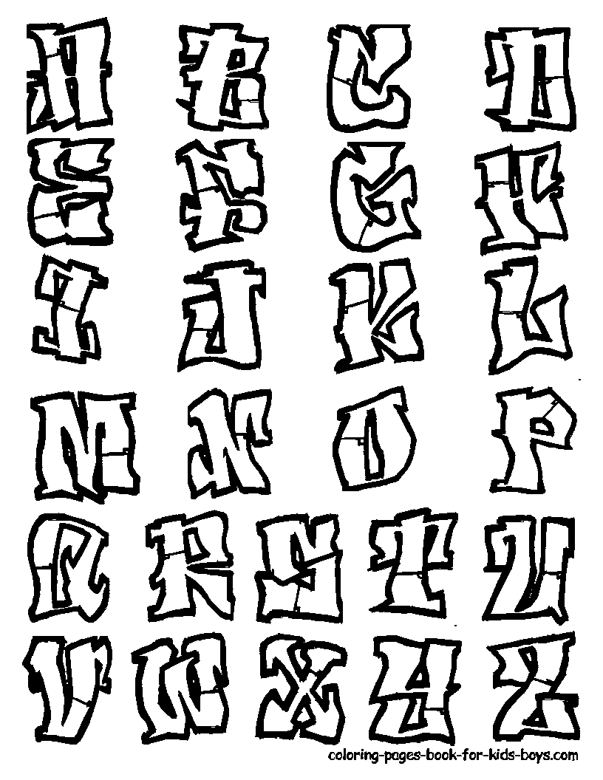[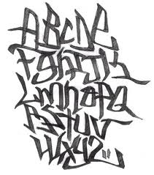](http://www.google.com/imgres?q=how+to+draw+graffiti+alphabet&hl=en&sa=X&biw=792&bih=425&tbm=isch&prmd=imvns&tbnid=GB3_VAV1oEZDeM:&imgrefurl=http://keusta.net/blog/index.php/2006/04/24/298-alphabet-graffiti&docid=klTsbfP86upmLM&imgurl=http://keusta.net/blog/images/graffiti/sketches/alphabet-graffiti.jpg&w=550&h=624&ei=cYrfTtPtBoGe2AXajtWLBQ&zoom=1&iact=rc&dur=0&sig=102033972592930107580&page=1&tbnh=88&tbnw=78&start=0&ndsp=12&ved=1t:429,r:2,s:0&tx=31&ty=27)[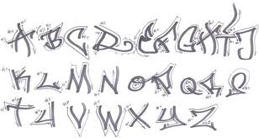](http://www.google.com/imgres?q=how+to+draw+graffiti+alphabet&hl=en&sa=X&biw=792&bih=425&tbm=isch&prmd=imvns&tbnid=54kRzZnqO21VwM:&imgrefurl=http://graffiti-alphabets.com/graffiti-alphabets-in-sketch-design/&docid=kMHqH55cj45qDM&imgurl=http://graffiti-alphabets.com/wp-content/uploads/2011/09/Draw-Graffiti-Alphabets-In-Sketch-Design.jpg&w=540&h=288&ei=cYrfTtPtBoGe2AXajtWLBQ&zoom=1)[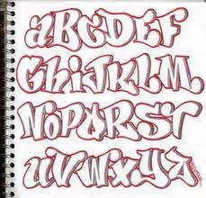](http://www.google.com/imgres?q=how+to+draw+graffiti+alphabet&hl=en&sa=X&biw=792&bih=425&tbm=isch&prmd=imvns&tbnid=ishPMe2EtzOeTM:&imgrefurl=http://grafitygraffiti.blogspot.com/2010/04/blackbook-sketch-alphabet-graffiti.html&docid=momqIDrjFU0eBM&imgurl=http://3.bp.blogspot.com/_36SFFFDlygA/S8OqDInFhFI/AAAAAAAAFsA/e9NC_So_O78/s1600/design%252Bsketch%252Bgraffiti%252Balphabet%252Bletters%252Bin%252Bthe%252Bpaper.jpg&w=391&h=375&ei=cYrfTtPtBoGe2AXajtWLBQ&zoom=1)[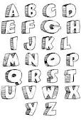](http://www.google.com/imgres?q=how+to+draw+graffiti+alphabet&hl=en&sa=X&biw=792&bih=425&tbm=isch&prmd=imvns&tbnid=M-Zd6vl1ax39ZM:&imgrefurl=http://grafitygraffiti.blogspot.com/2010/09/graffiti-alphabet-letters-z-caveman.html&docid=E0MP16mY4j9WMM&imgurl=http://2.bp.blogspot.com/_36SFFFDlygA/TJ1BcN7mJkI/AAAAAAAAHe4/wJnM4LsjGQY/s1600/Graffiti_Alphabet%252B_Letters_A-Z_Caveman_Design.gif&w=800&h=1202&ei=cYrfTtPtBoGe2AXajtWLBQ&zoom=1&iact=rc&dur=47&sig=102033972592930107580&page=5&tbnh=92&tbnw=61&start=48&ndsp=12&ved=1t:429,r:3,s:48&tx=32&ty=48)[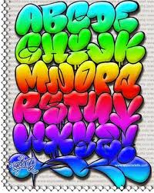](http://www.google.com/imgres?q=how+to+draw+graffiti+alphabet&hl=en&sa=X&biw=792&bih=425&tbm=isch&prmd=imvns&tbnid=sq7lJPsrLyCCgM:&imgrefurl=http://newcelebritycorner.onsugar.com/how-draw-graffiti-alphabet-letters-z-17409918&docid=tJRUPG-nvyAxLM&imgurl=http://2.bp.blogspot.com/_jjkox3SeGcY/Sw7-6SAgH-I/AAAAAAAAAKQ/Bht8zA0UAVE/s400/graffiti%25252525252525252Balp%252525252525252526amp%25252525252525253Bamp%25252525252525253B&w=319&h=400&ei=cYrfTtPtBoGe2AXajtWLBQ&zoom=1)