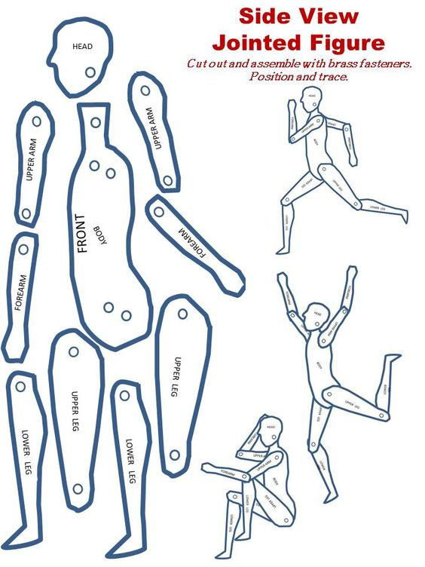
Movement Project
Step one: Cut out and assemble figure guide.
Step two: Create a concept of how you want your figure to move across the page. You can practice using the figure guide or use stick figures for this step.
Step three: On final draft paper use the figure guides to lay out your three movements. Remember to draw lightly so that all graphite lines can be covered later by color pencil.
Step four: Select the analogous color scheme you would like to use to color in your figure and the motion lines.
Step five: Using a selection of color pencil techniques including (layering, blending, gradient, and varied pressure color in you three figures with each figure being one color in the analogous color scheme. Keep in mind you can layer colors when figures overlap.
Step six: Using a ruler add motion lines in the areas of the figure that are being propelled in motion. Remember to use a pattern of the same analogous colors as your figures.
Step seven: Write your name in pencil on the back and turn your completed project in.

